# Pizza Order User Manual

Adam Laloge - SDEV140

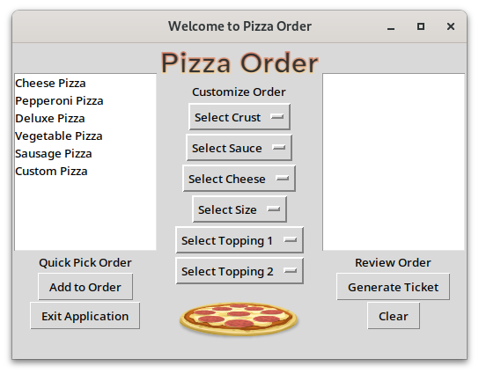

Welcome to Pizza Order!

### User Interface Overview

* Quick Pick Order
  + Make a Quick Pick selection from the left-most side to start your order.
* Customize Order
  + Customize your quick pick selection with the variety of drop-down options.
* Review Order
  + Get an overview of your current order before generating a ticket on the right-most side.
* Buttons
  + Add to Order – Adds Current Quick Pick Selection to Order
  + Generate Ticket — Generates a new ticket window to display item pricing.
  + Clear — Clear the order cart and start over.
  + Exit Application — Close the Application

### Steps to Place Order

1. Make a Quick Pick selection, or choose Custom Pizza.
2. Customize order by selecting drop-down choices in the Customize Order menu.
3. Click Add to Order to add the currently selected and customized order to cart.
4. Click Generate Ticket to create an order summary and price list.
5. Exit Application

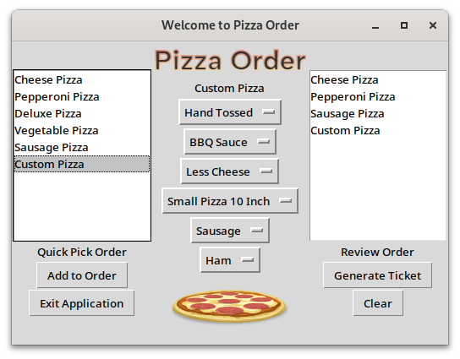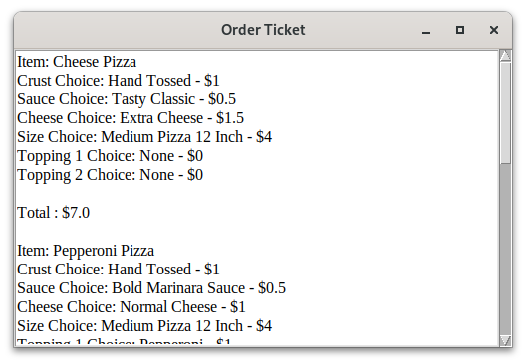

Thank you for using Pizza Order!